CS 255 System Design Document
By Jacob Greer
February 22, 2026

UML Diagrams

UML Use Case Diagram
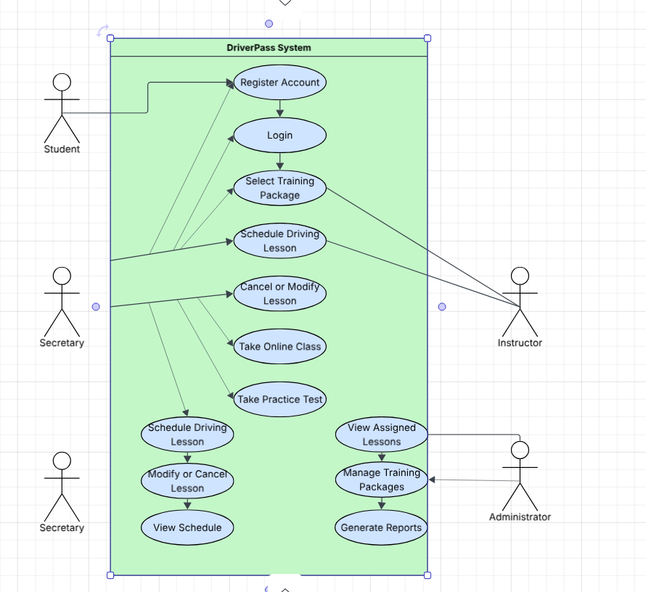

UML Activity Diagrams
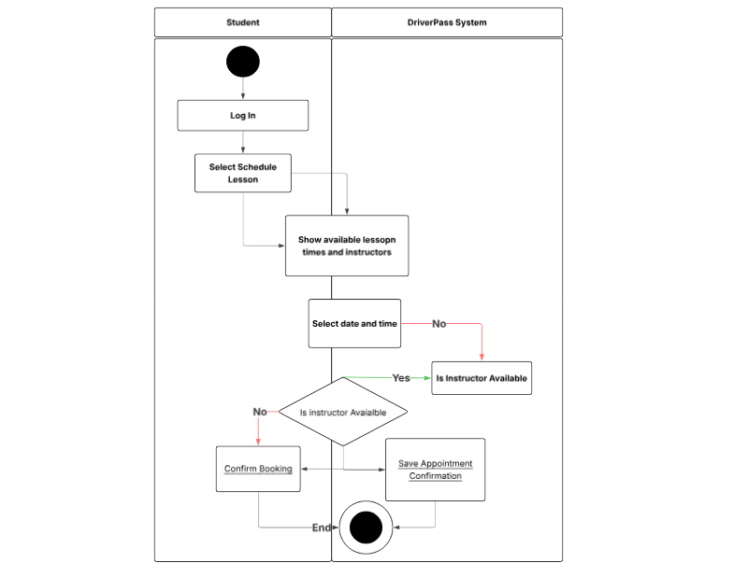

Activity Diagram 2:

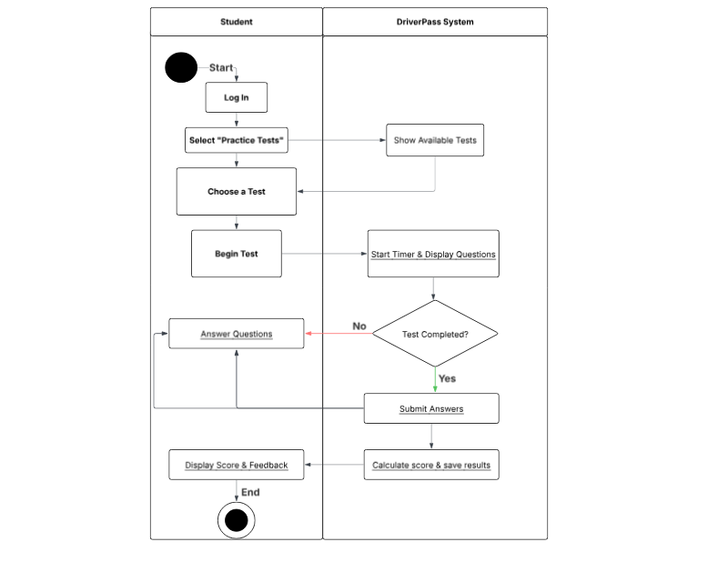

UML Sequence Diagram
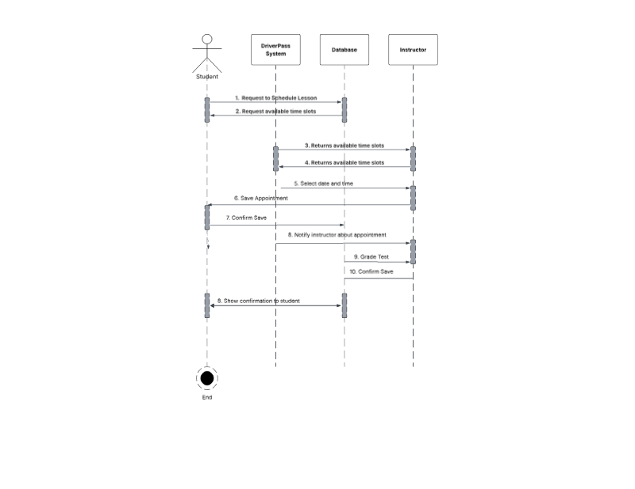

UML Class Diagram
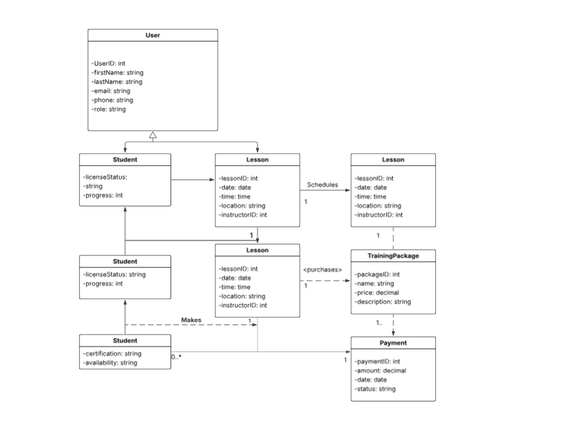

Technical Requirements

The DriverPass system requires specific technical components in order to operate effectively, securely, and reliably as a web based application.

- Software Requirements
- Web server software such as Apache or Microsoft IIS to host the DriverPass website.
- Cloud based hosting so the system can be accessed online from any device.
- Database software to store user accounts, lesson schedules, test results, and payment information.
- Secure login system with password reset capability.
- Encryption to protect personal and payment data.
- Backup software to regularly save system and database data.
- Ability to receive updates from the DMV for rule and test changes.

- Hardware Requirements
- Stable internet connection.
- Cloud server or dedicated server to host the system.
- Enough storage space for system and database information.
- Computer, laptop, tablet, or smartphone to access the website.
- Firewall or network security device for protection.

- Security Requirements
- Role based access for different types of users.
- Encrypted usernames and passwords.
- Activity logging to track scheduling and account changes.
- Secure payment processing.

- Infrastructure Requirements
- Cloud based environment.
- Centralized database system.
- High system availability with minimal downtime.
- Hosting within the United States.

